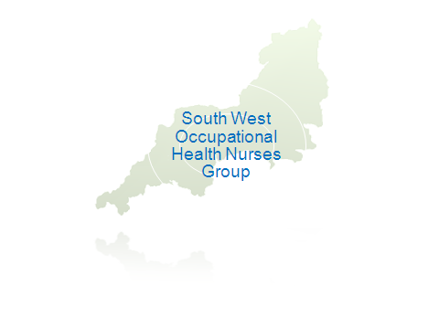Application for a South West Occupational Health Nurse Group Bursary
1. Your details (PLEASE COMPLETE IN BLOCK CAPITALS)
Surname/family name:
Forename:
Mr/Mrs/Miss/Ms
E-mail address:
Home Address (including postcode):

Home telephone number: Work telephone number:
Job Title: Place of Work:

Please give brief details of present post (attached CV will be accepted):

Have you previously applied for a bursary from the SW OHNG?
When was this application made?
Was an award made?
What was the award used for?

2. Programmed study/book title
Date of study : Book Title:
Breakdown of costs (please estimate where necessary)
 | £
 | £
TOTAL | £
3. How will the chosen programmed study or book request enhance or change your practice?

4. How will this benefit your clients?

5. Professional Education (since working as an Occupational Health Nurse or other relevant courses)
Name and address of training institution | From (Month/Year) | To (Month/Year) | Title of Course

6. Further information
Please give details of how your experience, skills and training are relevant to the programme of study/course together with any other information in support of your application (in no more than 200 words).

- Please enclose one copy of your completed application form.
- We regret we are unable to accept applications by fax or by e-mail.
- The committee may contact you for further information and/or informal interview.

I acknowledge that the decision of the committee is final.

Signed Date _________________

