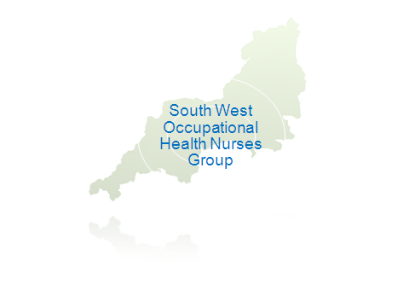

South West Occupational Health Nurses Group
30th Anniversary Annual Conference

Thursday 1st May 2014
Sandy Park Conference Centre, Exeter

APPLICATION FORM

Full Name:

Mailing Address:

Post Code:

Job Title:

Employer:

Preferred contact telephone:

Email address:

Dietary requirements:

Please check this box if you do not wish your email address to be placed on delegate list

DELEGATE FEE (please check box)

SWOHNG member: £60
Non-member: £85
PAYMENT OPTIONS

Internet banking: payment by BACS to Account No: 01667945 Sort code: 30-95-08
Please enter the payment reference you will be using for your internet payment

Cheque: payable to South West OHN Group

PLEASE SEND COMPLETED FORM/CHEQUE TO DAWN VEAL (Treasurer):

Form by email: dawnmveal@sky.com

Form/cheque by post: Dawn Veal, Rose Barn, Berry Cross, Langtree, Devon EX38 8NU

Cancellation policy – refunds cannot be given for cancellation within 2 weeks of the study day. However another person may use the delegate place instead.

* CLOSING DATE FOR RECEIPT OF APPLICATION & PAYMENT IS 15TH APRIL 2014 *

Office Use
Date form received
Date payment received

