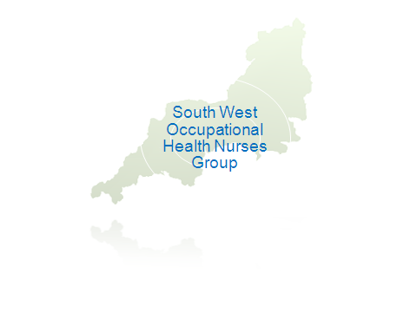CONSTITUTION

1. NAME OF THE GROUP
South West Occupational Health Nurses Group.

2. AIM
To raise the profile of occupational health in the south west.
3. OBJECTIVES

The main objectives are to:

- Provide a forum for discussion and support for occupational health nurses and occupational health technicians working in the south west.

- Provide an opportunity for development and communication of information and matters of common interest in the group.

- Promote the role of the occupational health nurse in the field of health, safety and welfare at work.

- Enhance communication networks within the occupational health field.

- Improve, encourage and provide continuing education in occupational health.

4. MEMBERSHIP

The group shall comprise of all those health care professionals working in occupational health throughout the south west.

5. SUBSCRIPTIONS

Subscription rates will be reviewed annually. Annual subscriptions to the group are payable by 31 March.

6. Executive Committee

- The Executive will be a minimum of 4 elected honorary officers who will comprise of: Chair, Vice Chair, Secretary and Treasurer (Appendix A). Committee meetings will be held at regular intervals as required.

- The honorary officers will have the responsibility for the day to day running of the group.

- The membership of the committee should not exceed 6 members.

- Honorary officers are eligible to stand for a maximum of three terms on the committee and then demit committee membership for a minimum of 1 year before being eligible to stand for re-election.

- Elections shall take place every 2 years.

- The term of office shall begin at the close of the Annual General Meeting in the year of election.

7. VOTING

Where two or more nominations are received for any one office, voting shall be by a show of hands.

All elected honorary officers shall have equal voting rights.

8. QUORUM

No business shall be agreed unless 75% of the committee is present. To agree an urgent way forward, committee members must be contacted via email/letter, requesting a written response within a given time scale for consideration at the next committee meeting.

9. FINANCE

- Any monies held by the group may only be used for purposes which accord with the aims and objectives of the group.

- Funds will be generated from conferences, sponsorship and advertising on the website.

- The committee members of the group shall decide when and how the monies should be spent.

- In the event of the South West Occupational Health Nurses Group dissolving, such funds that are currently held will be disposed of as agreed by a specially convened extraordinary meeting of members.

10. BURSARIES

- Bursary applications shall be in before 31 August every year. Applicants should have been members of the group for two consecutive years.

- Cheques will be issued retrospectively.

- A maximum of two bursaries a year may be awarded, and only once every two years to an individual or company.

11. MEETINGS

Study days will be held at least annually. Guest speakers may be invited, to encourage attendance for continuing professional development.

Committee members are entitled to attend the study day free of charge.

ANNUAL GENERAL MEETING
The AGM shall be held annually each Spring and will include:

- Election of executive committee
- Discussion of agenda and any other business
NOTICE OF THE ANNUAL GENERAL MEETING

The notice of the AGM election of officers, for which nominations are required, shall be given one month beforehand.

12. TRAVEL EXPENSES

Committee members are entitled to claim travel expenses at the rate set by the UKMRC to attend committee meetings only. Travel cannot be claimed to and from study events.

13. AMENDMENTS TO THE CONSTITUTION

This constitution shall remain in force until amended by not less than 75% of the eligible members present. One month prior to the anticipated review the constitution should be distributed to members of the group for approval.

APPENDIX A

Duties and Responsibilities

Chair

- To delegate tasks to committee members pertaining to group business.
- To act as the link between all members of the group in the south west.
- To liaise with speakers for study sessions.
- To be responsible for the group website acting in liaison with the treasurer.

Vice Chair

- To deputise in the absence of the chair.
- To organise and arrange suitable sponsors for study days.

Secretary

- To support the chair and the committee by maintaining regular, effective communications between the members and the committee.
- To keep a record of all correspondence received for the group regarding membership.
- To take notes at meetings and distribute the minutes to all members no later than 2 weeks following the meeting.

Treasurer

- To be responsible for all monies received and outlaid from the South West Occupational Health Nurse Group
- To ensure that all costs incurred by the group are paid on time and supported by appropriate receipts.
- To prepare an annual report for the Spring AGM.
- To arrange for the groups funds to be audited at least two yearly.

Review date Spring 2013

