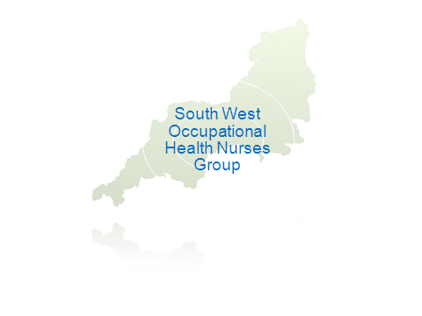
SOUTH WEST OCCUPATIONAL HEALTH NURSE GROUP
MEMBERSHIP APPLICATION FORM

Please complete in block capitals

PERSONAL DETAILS

Full Name:

Mailing Address:

Post Code:

Job Title:

Employer:

Telephone  Numbers: | Day | Evening | Mobile
Email Address:

OH Areas of Interest

Please tick this box if you do not want your contact details on the membership list

MEMBERSHIP

Membership runs from 1st January to 31st December each year
Payment must be received by 31st March

Please cross the appropriate boxes

Full Membership (£10) |  | Benefits All members are entitled to attend Regional group meetings, and receive regular communications from the area including job vacancies.  Website access.  Subsidised annual study day
Retired members are entitled to free membership. Please tick if applicable

£10.00 by cheque made payable to South West Occupational Health Nurses Group

Please return this form with your payment to and return to: RCN OHNG SW Treasurer:
Alison Presswell, 35 Chatsworth Way Carlyon Bay St Austell PL25 3SN

Office Use – Date payment received

